**Disclaimer!!!**  
 The Prototype is not completely completed and the features are very minimal since integration of Front-end and Backend is not complete.  
  
  
**AI Conversation Logs**

1. Brainstorming with Gemini and Chat gpt

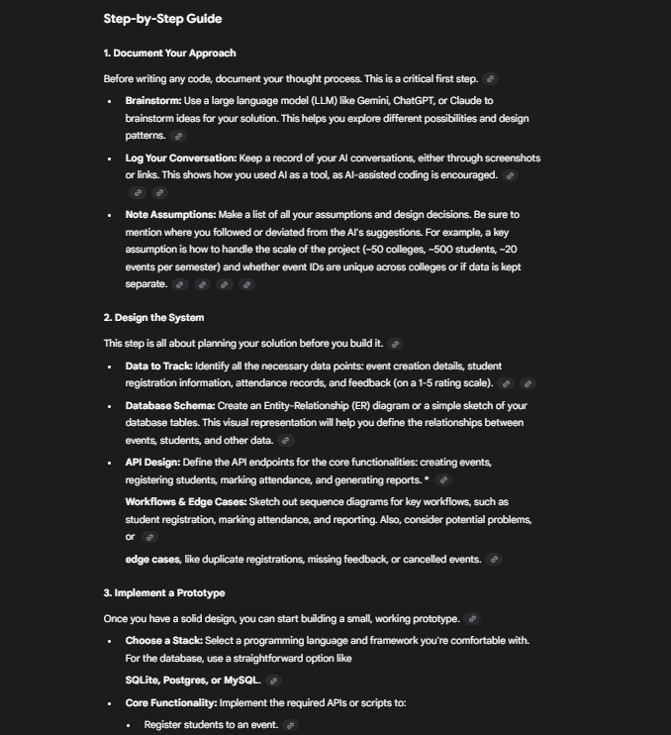 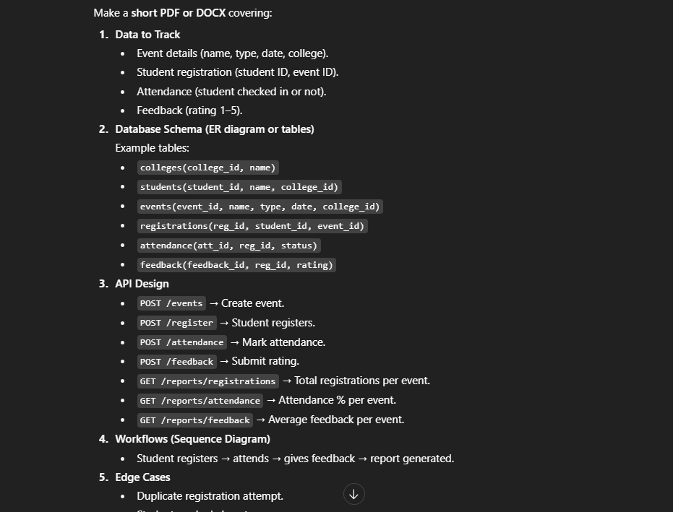

1. Design UI for Admin Page using Gemini  
     
   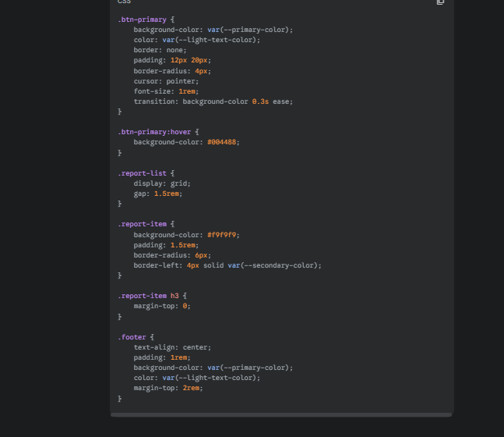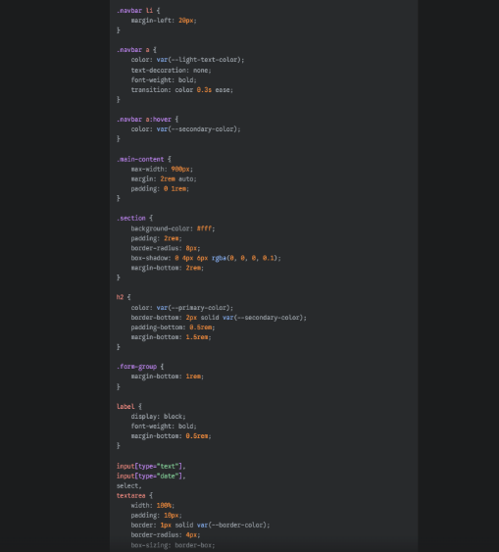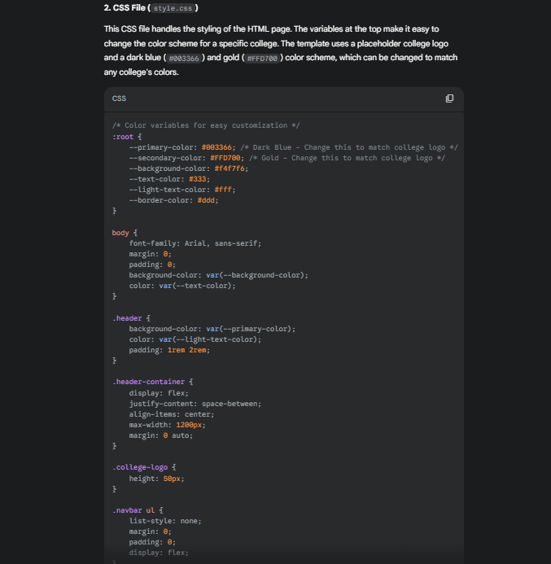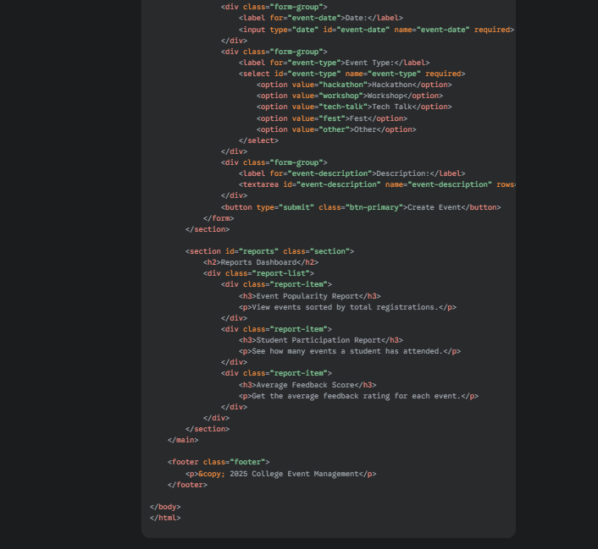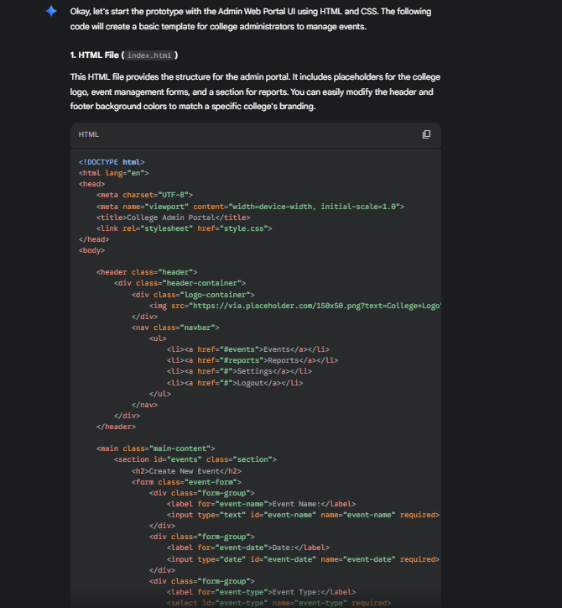
2. Some Ui changes using Chat gpt

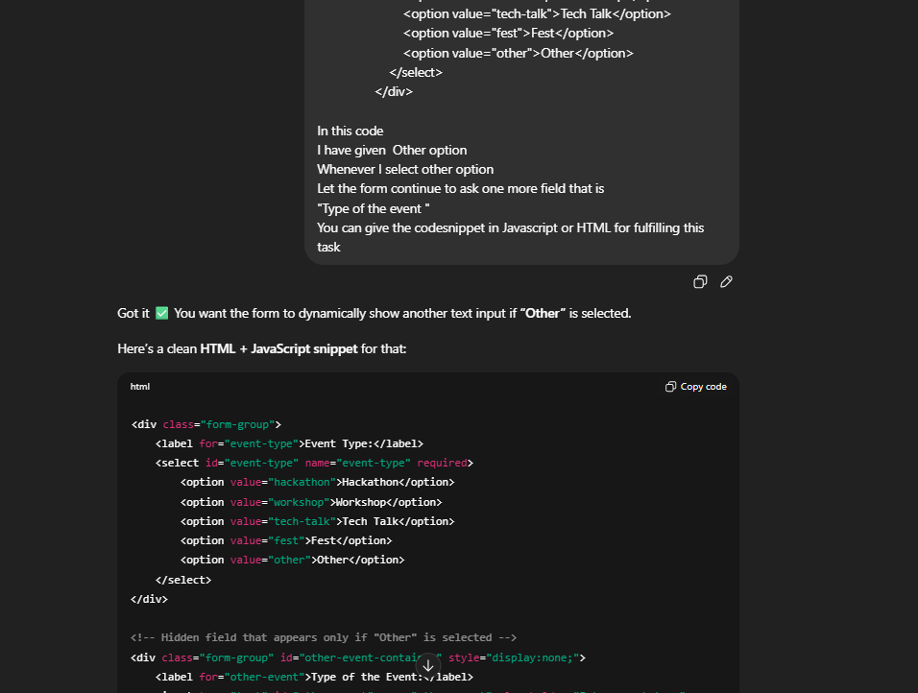

1. Student Portal UI using Gemini  
   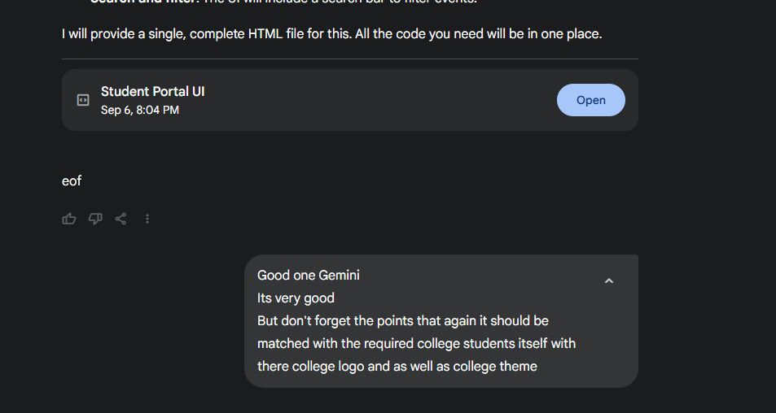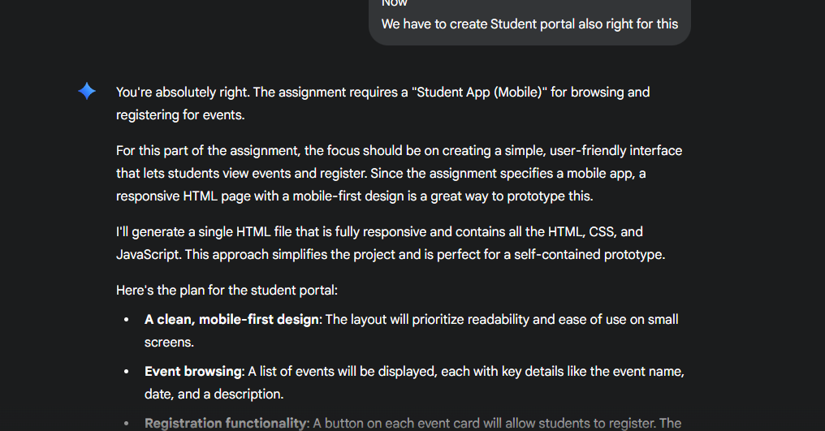
2. Creating Login Page   
   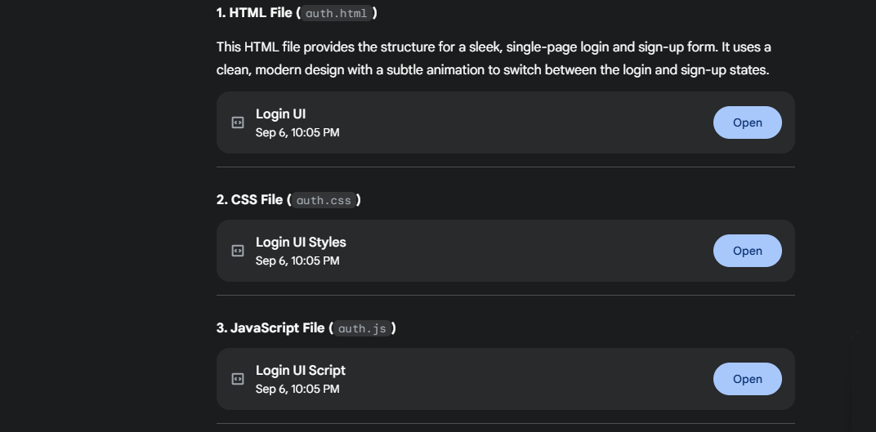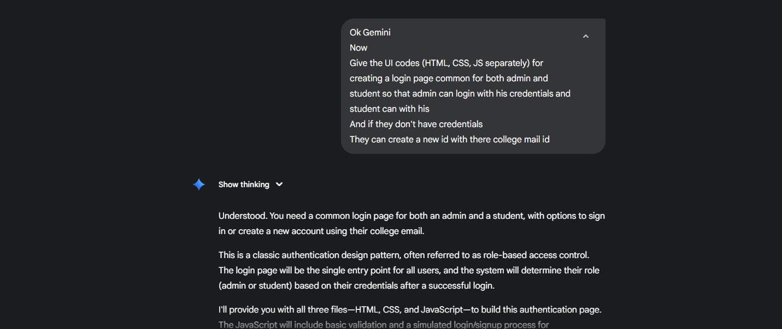
3. Create a mock database using MY SQL with the help of Gemini  
   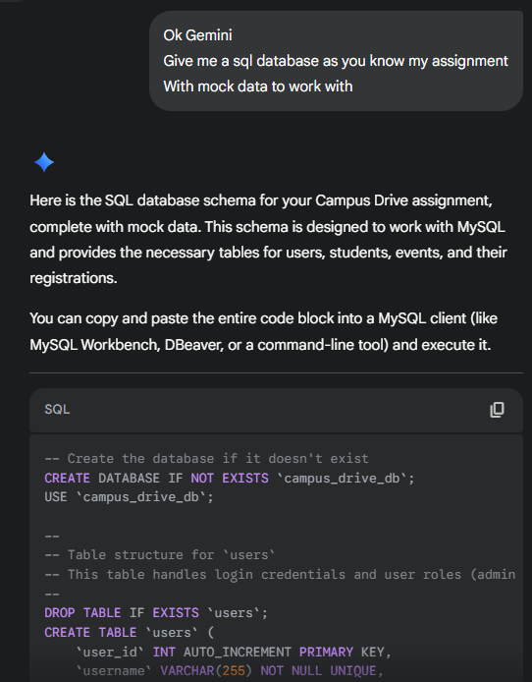
4. **Note:** Back-end and integration was not good with Gemini  
   Therefore tried Backend on my own skills  
   Henceforth with problems in integrating which when asked to Gemini deviated from topic to something unrelated and unwanted errors   
   Hence forth the prototype not completely complete  
   But completely worked on.
5. Designing a Document assignment was done using Chat GPT:

